16720: Computer Vision

HW 6: Photometric Stereo

Harsh Dhruva

AndrewID: hdhruva

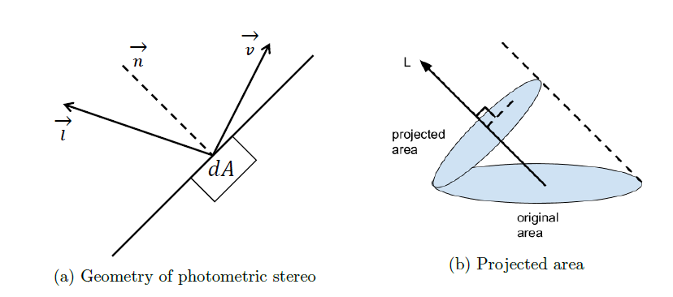1 a)

In the n-dot-l lighting model above, $\vec{l}$ represents the lighting direction or the source direction, $\vec{n}$ represents the surface normal to the area dA, and $\vec{v}$ represents the viewing direction. Lets say the angle between the source and the surface normal is $θ$.

The dot product comes from the assumption that the object is Lambertian and therefore follows the Lambert cosine law, that says that the amount of light received by the user is proportional to $cosθ$ which is $\vec{n} . \vec{s}$ assuming directional unit vectors.

According to the Lambertian cosine law, if the value of $θ$ is zero then, $cosθ$ = 1, which means the maximum intensity will be when the source direction is the same as the surface normal. So we can assume the light source at an angle $θ$ to the original area dA is equivalent to the light source normal to the projected area dA $cosθ$.

We assume diffused reflection which means the surface appears bright from all directions therefore it is independent of the viewing direction.

1 b)